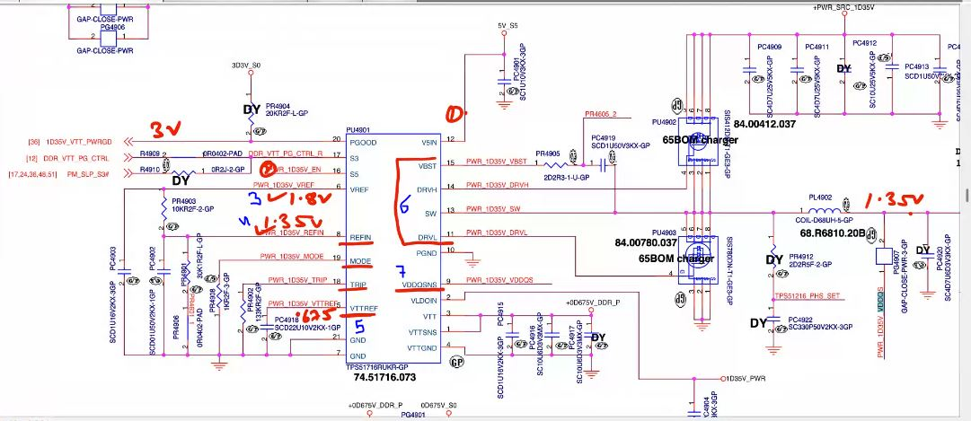
IC Requriement
- VCC ~5/19V
- EM1 -S5 (3.3V) – for coil supply VDD
{VCC+EN} Output FeebBack PowerGood
Output se pehle IC apne aap ko set krti ki kitni voltage kitni frequency
- VREF – Generate hota hai…(1.8V)

- Refin – as per voltage devider (1.3v isse se pata chalta hai itna vol banana hai)
- Mode
- Trip
{Refin, Mode, Trip} ke bas resister check krne hai

- Output Generat - {VBST, DRVH, SW, DRVL} 1.3v
- VTTREF .675v
- VDDQSNS- feedback 1.35v

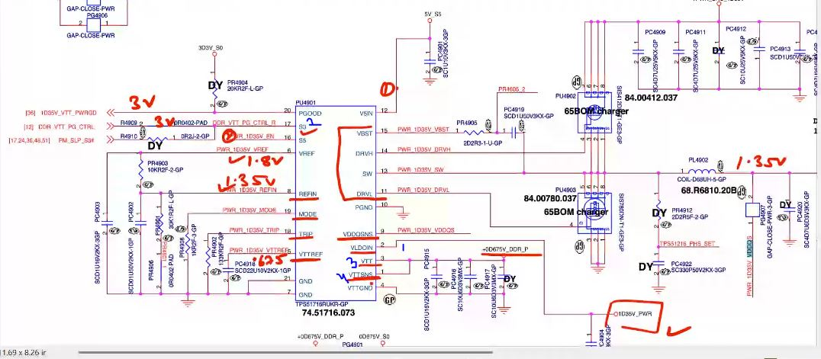
- VLDOIN = VCC = generated VDDQ
- En- S3 3V
- VTT - output .675 v
- VTSNS - feedback

